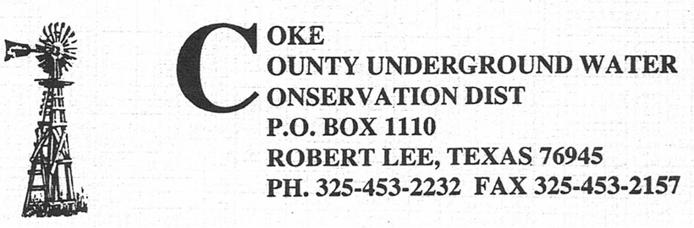

The Coke County Underground Water Conservation District will hold a called Business Meeting of the Board of Directors on Tuesday, December 10, 2024 at 5:00 pm in the district office in the Coke County Courthouse 13th East 7th Street, Robert Lee, Texas.

Agenda:

1. Call Meeting to Order

2. Public Comments

3. Discussion and action to adopt proposed changes to CCUWCD Rules and Regulations

4. Discussion and Action to adopt CCUWCD 2024-2029 Management Plan

5. Discussion and Action regarding Telicon Services.

6. Discussion and Action regarding TAGD annual membership renewal.

7. Other Business

8. Adjournment